Revision Notes and Questions

Change Log
- Minor edits to abstract to make it more clear, among other grammatical edits in body of paper.
- Added sentence about mid-latitude noise obscuring ENSO signals in the introduction, citing Deser papers. Added more details to P4 of section 3.2 on the CalCS ensemble spread.
- Added (to) paragraphs in discussion:
  - Discussion of effects of anthropogenic climate change on our results
  - Additional discussion in P5 of comparing and contrasting systems
  - Added paragraph discussing the sDIC decomposition to look at relative impacts of biology, circulation, and CO2 flux on the sDIC tendency anomalies.
  - Added to final paragraph regarding how much variance we were able to describe for these systems.
- Added bar plots of monthly internal variability to figure 3, violin plots to figure 4.

Questions
- In introduction paragraph 1:
“This process also supplies waters with an elevated dissolved inorganic carbon (DIC) content, which enhances the partial pressure of carbon dioxide pCO2 and reduces the pH and carbonate ion concentration.”

Mike A. suggests we follow this with a sentence explaining why for non-BGC people. Is this necessary in Biogeosciences?

- Mike A. suggests I compute the std. dev. For CESM-LENS and SOM-FFN to compare variability
  - However, this seems problematic since we know that SOM-FFN has suppressed variability. Would we expect it to be the same? Is this necessary?

- What should we do about the CalCS – NPGO decomposition discrepancy? My results at the bottom of this document show that it is a systematic bias and must be directly due to the higher-order and cross-derivative terms. The results of Doney et al. 2009 and Long et al. 2013 (that the decomposition method doesn’t change influence of higher order terms) doesn’t apply here, because we can isolate those non-linear terms as being important. Should we attempt to quantify this directly?
  - I think we can go up to second order for U, S, Alk, and DIC since those terms remain in our first-order sensitivity. However, how do we compute, e.g. $∆U$²? Is this $(∆$U)² or $∆(U$²)? If the latter, we’d have plenty of uncertainty due to taking the square of monthly averages.

sDIC Decomposition Results

Table 1. Regression coefficients between given EBUS and climate index for anomaly time series of the estimated contributions toward the sDIC tendency integrated over the upper 100m and the total surface area of the system.
Term | CalCS – NPGO | HumCS – Nino3 | CanCS -- NAO
CO2 Flux | -0.076 $±$ 0.020 | -0.484 $±$ 0.061 | 0.051 $±$ 0.021
Circulation | 0.147$±$ 0.064 | -0.387 $±$ 0.128 | 0.002 $±$ 0.056
Biology | -0.068 $±$ 0.048 | 0.861 $±$ 0.081 | -0.049 $±$ 0.054
$Σ$ terms | 0.003 | -0.010 | 0.004
sDIC Tendency | 0.003 $±$ 0.001 | -0.010 $±$ 0.002 | 0.004 $±$ 0.001
Units are Gg C yr⁻¹
Uncertainty is 1 std. dev. spread of the ensemble
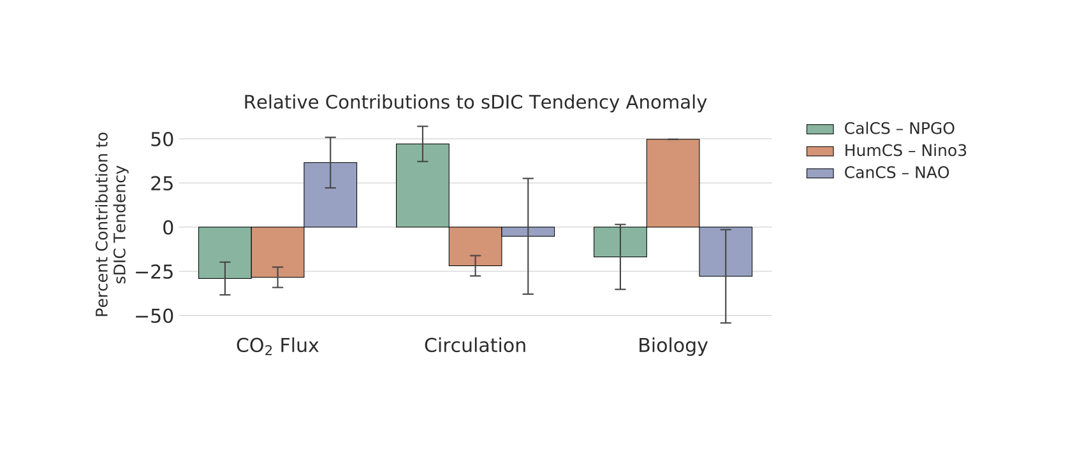

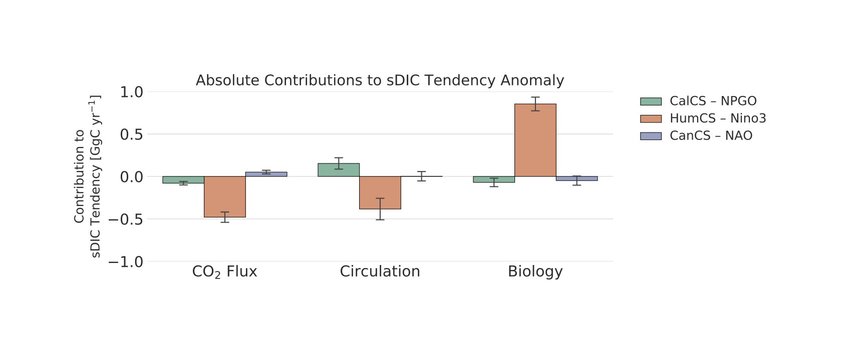

CO₂ Flux Decomposition Discrepancy

Issue: When approximating the regression of CO2 flux onto the NPGO in the California Current, there is a large discrepancy between the approximation and the true regression (on the order of 100%).

This is unlikely to be due to the regression ΔF itself, as a look at CO2 flux residuals (Y) vs. the NPGO (X) yields a fairly linear relationship.

A comparison between the approximation (sum of individual contributions) versus the direct regression at every grid cell reveals that this is a persistent bias across the whole region. In other words, there are not certain sub-regions that drive this bias. This likely suggests that it is the higher-order and cross-derivative terms that lead to this issue.

Further evidence is shown by looking at the individual terms and the ensemble spread. It’s pretty uniform across the system.

